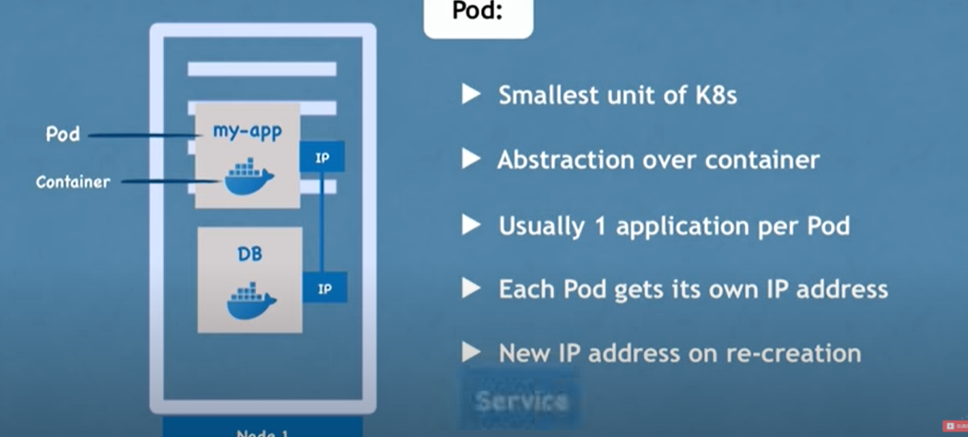

If Pod is down or crashed then new Pod will be created but here again IP address wil change for new Pod to counter this Service is used instead of IP wrt each POD. Thus IP not getting changed every time new POD is created.

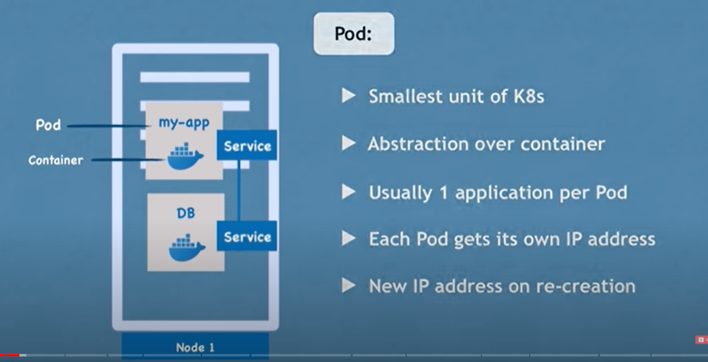

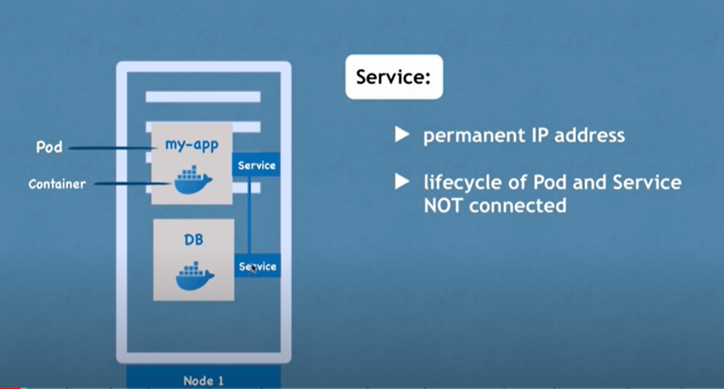

2)Ingress: helps to connect PODS to outside world i.e. outside Node.

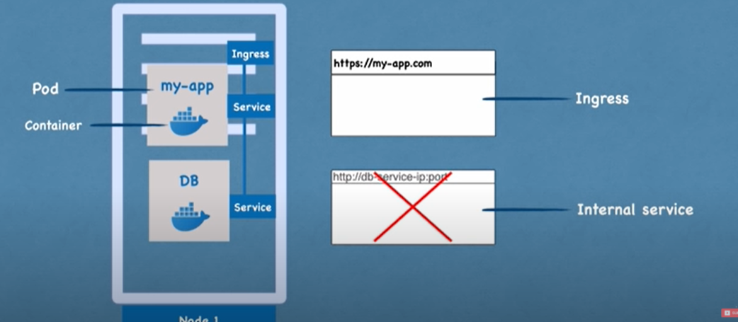

* 1. ConfigMap and Secret: if DB details are changed then no need to build image again.(Put password in Secret data)

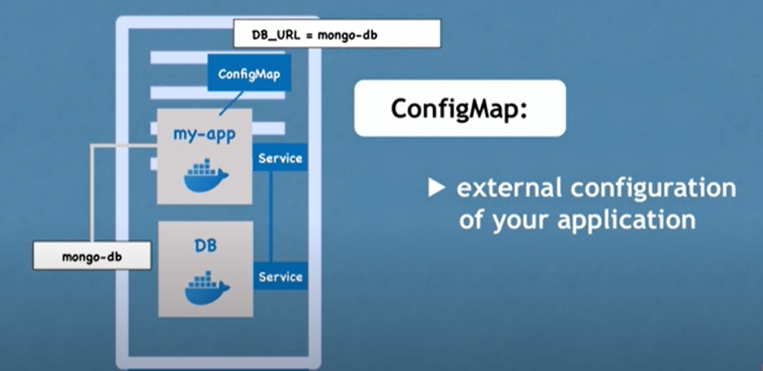

4)VOLUMES:: Data Storage

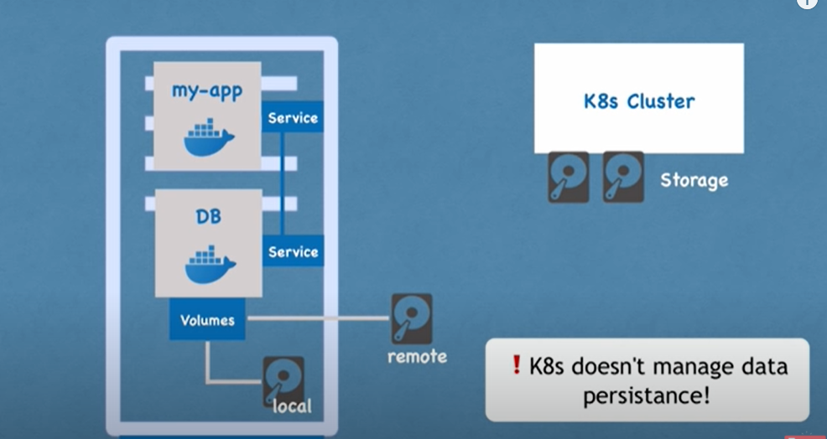

* 1. Service also act as Load Balancer.

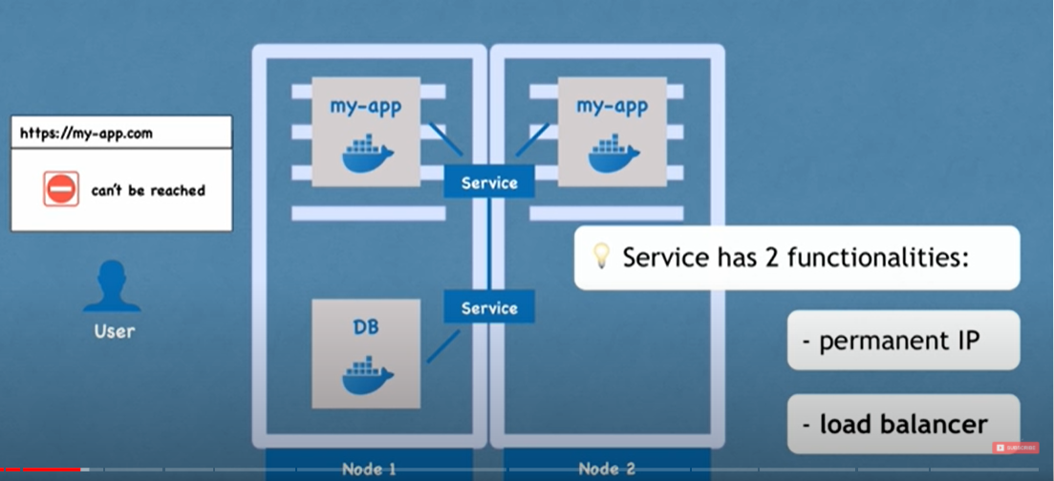

7)We don’t replicate literally i.e. we don’t create same POD on a different Node as a Backup rather we create Deployment where we can define how many replicas of that POD exactly we need.

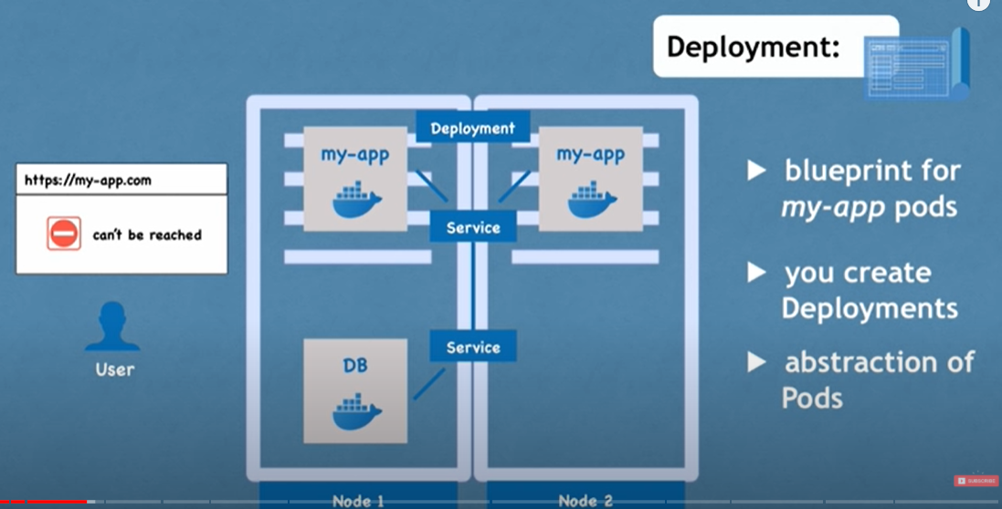

8)

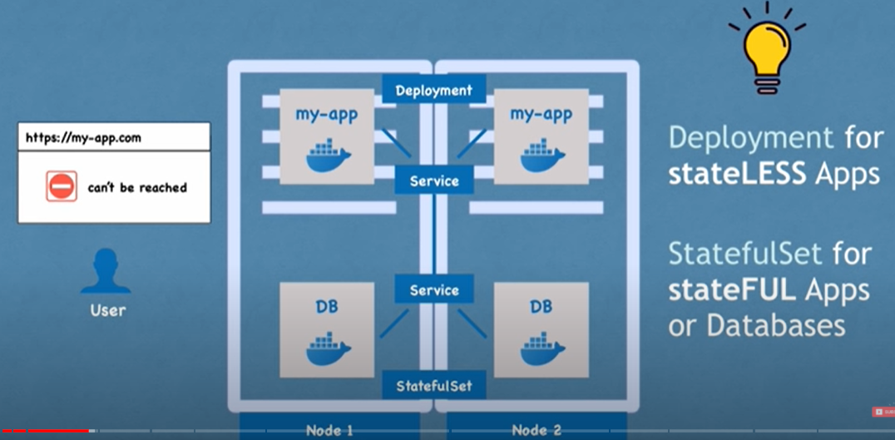

===================== Architecture =================================

9)Nodes or Worker Nodes:

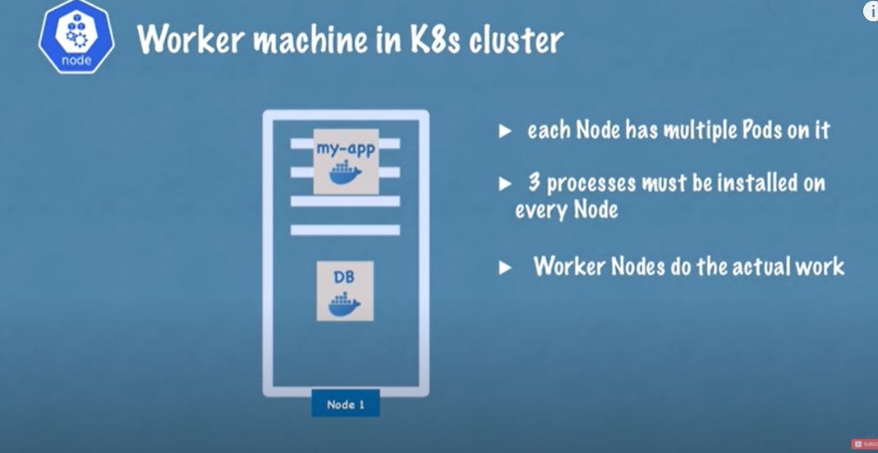

Kubelet :: interacts with both - the container and Node. It starts the POD with a container inside.

Container Runtime ==>

KubeProxy ==> Communication between Nodes.

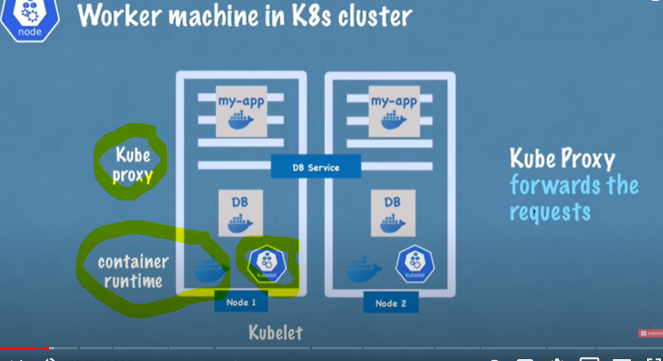

* 1. Master Node:

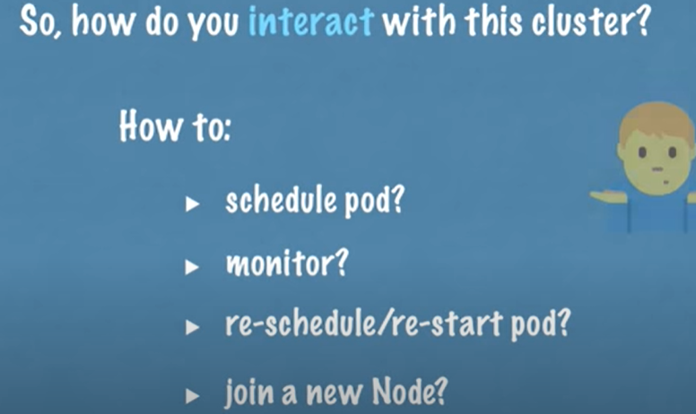

* 1. API server ::: only 1 entry point in to Cluster.

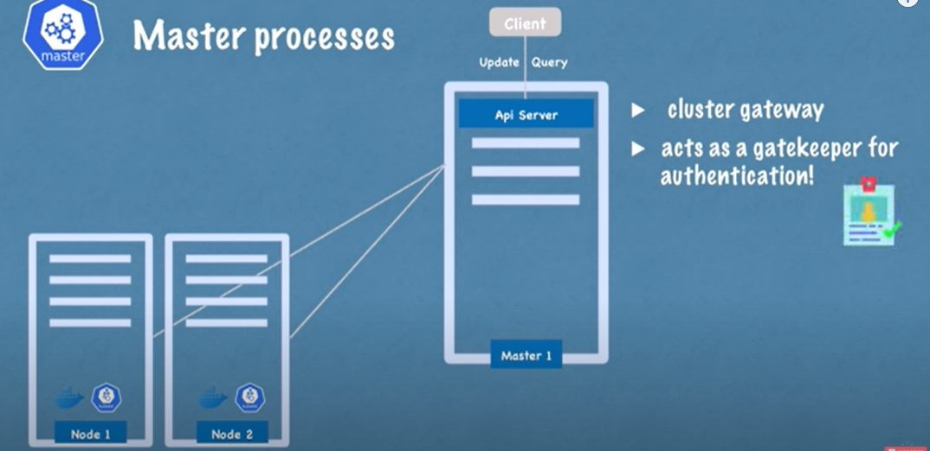

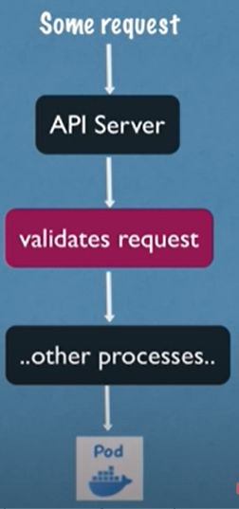

* 1. Scheduler :: Real processing or starting of POD in to Node is done by Kubelet.

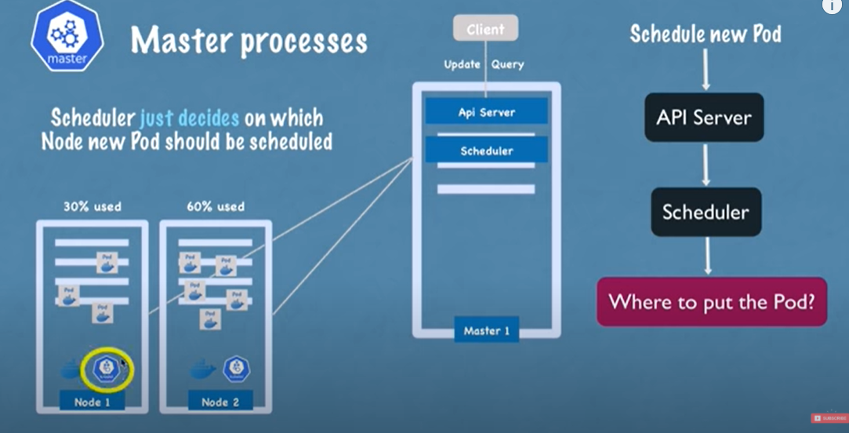

* 1. Control Manager: Suppose if any POD dies/crashes there should be some way to get an idea for that POD and here comes into picture Controller Manager.

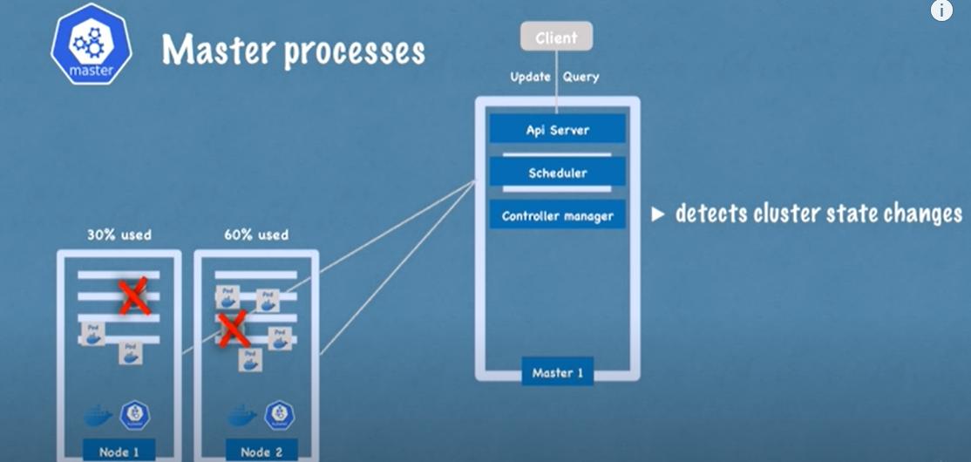

13)etcd: used to store Cluster State Information.

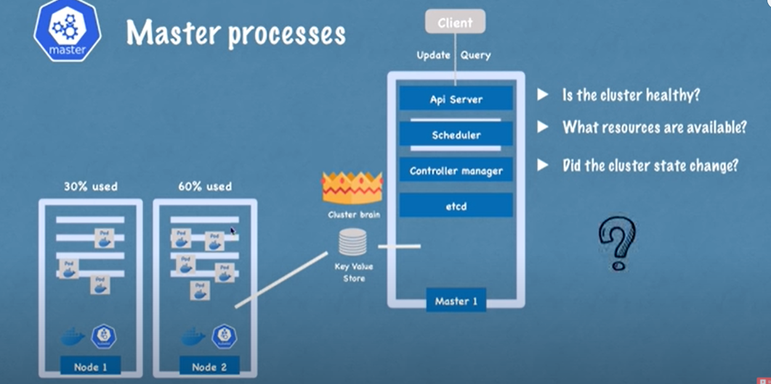

* 1. So there are multiple Master Nodes present in K8 cluster. API service is load balanced and ETCD is distributed storage across all Master Nodes.

=========================== Cluster Setup=======================

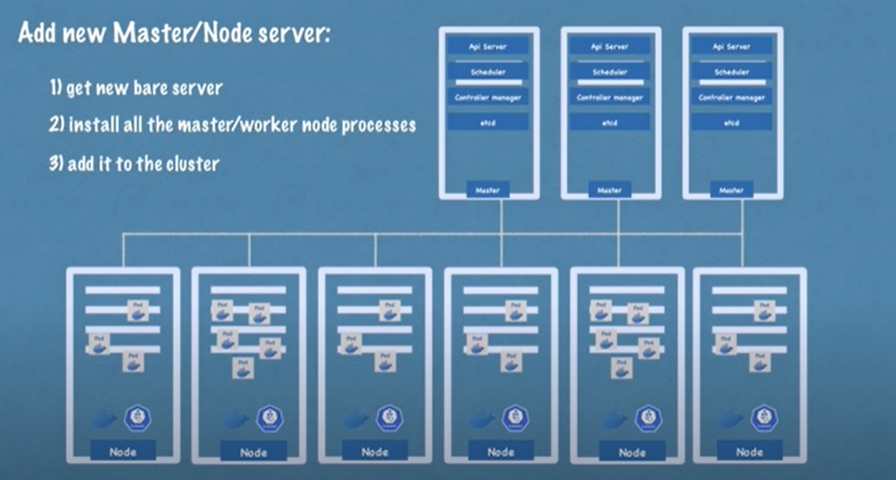

15)

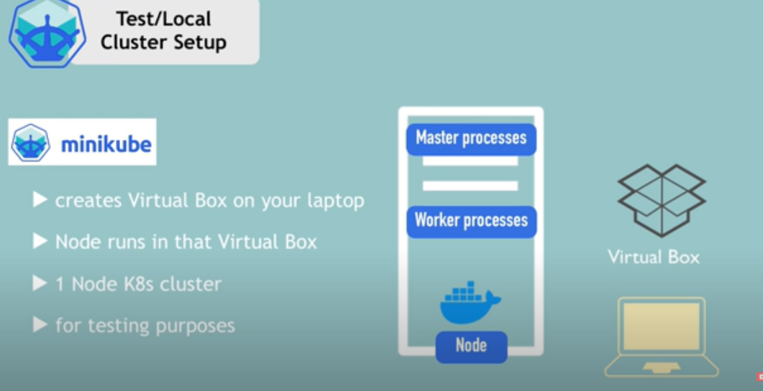

16)

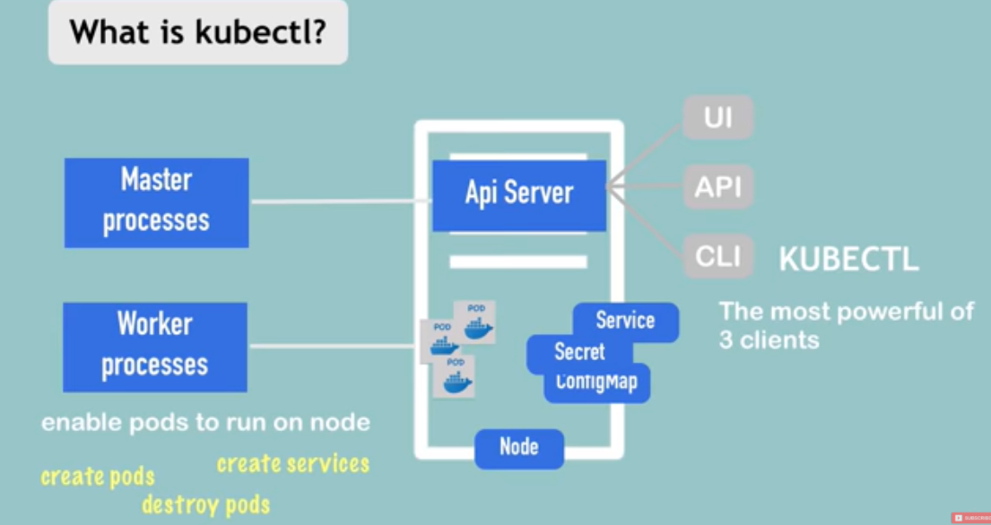

**Kubectl commands:**

Kubectl get nodes

Kubectl version ==> both client and server version should be present.

Kubectl get pod

Kubectl get services

Kubectl get -h ==> help command

WHEN WE WANT TO CREATE POD , DIRECTLY THERE IS NO COMMAND TO CREATE POD RATHER WE CREATE DEPLOYEMNT (I.E. Wrapper for POD) ==> it is Blueprint of POD.

-Kubectl create deployment nginx --image =nginx ==> will get nginx image from docker hub.

-Kubectl get deployment

-Kubectl get pod

-Kubectl get replicaset ==> managing replica of POD.

-Kubectl edit deployment nginx ==> we will get autogenerated config file with default values. Here we can edit it and save it(:wq) ==> automatically underlying POD is getting generated/update wrt new config files.==> get it validated using => kubectl get pod == old POD gone and new POD created.

==== Debugging PODS=====

Kubectl logs podName ==> basic log details.

Hubectl describe pod podName ==> more details descriptive one

Kubectl exec -it podName -- bin/bash ==> interactive Terminal ==> now this cmd will lead us to terminat of underlying container/image..run allcommands like ls and all.

Kubectl delete deployment nginx

Use config file as part of Config File Name:(Config file is saved as .yaml file)

Kubectl apply -f "config file Name" ===> to avoid entering so many values from command prompt..===> Both Create and Deploy.

Name==> name of deployment.

Spec :: ==> 1st One wrt Deployment and 2nd Spec wrt POD.(Specific container).

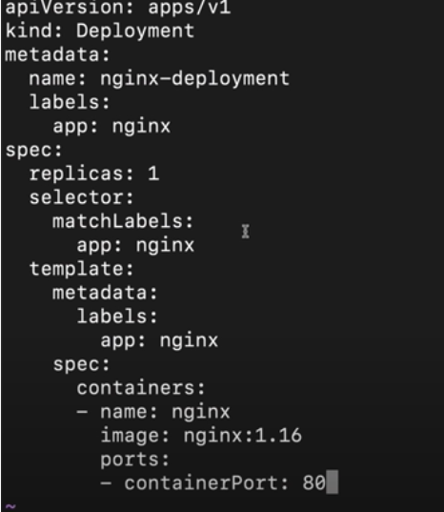

EVERYTHING BELOW DEPLOYMENT IS HANDLED BY KUBERNETES.

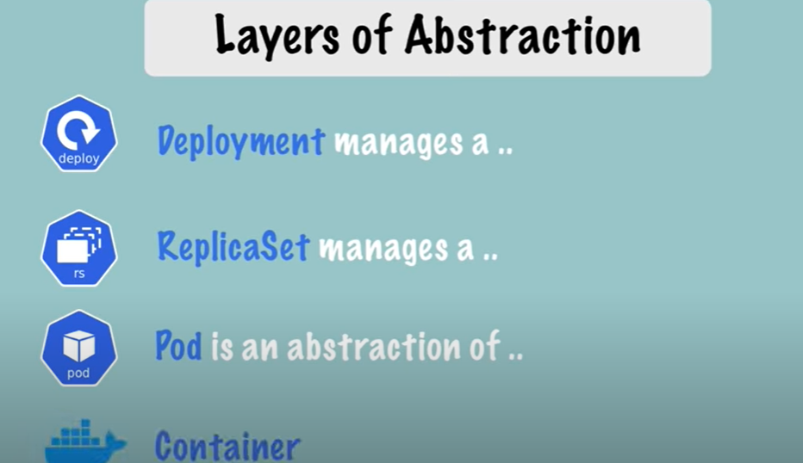

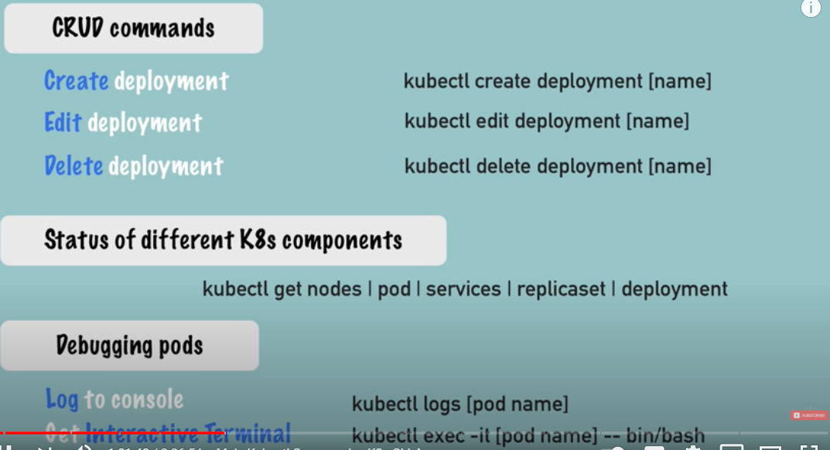

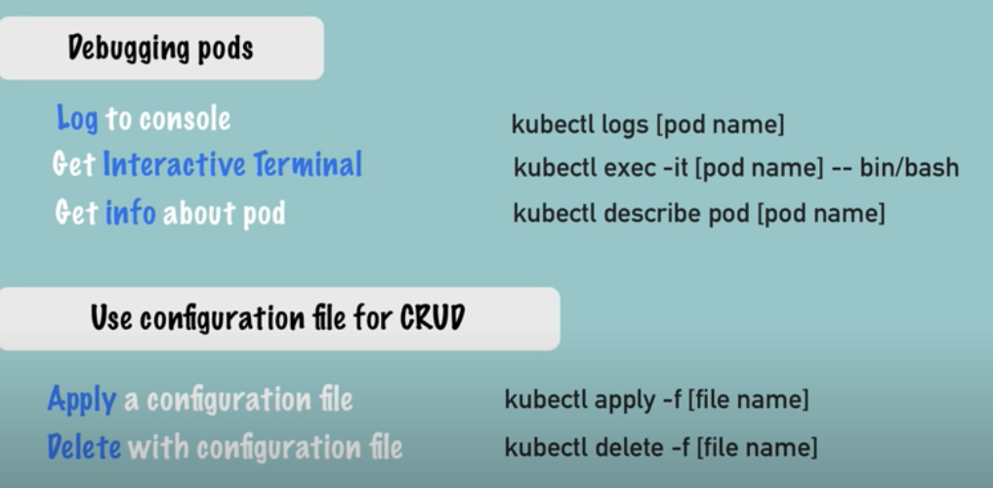

* 1. **=============== YAML Configuration File =================================::**

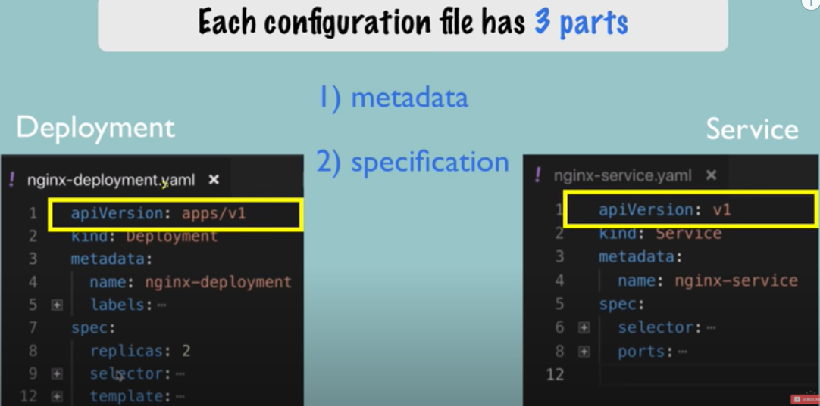

Here total 3 parts are there. And 3rd Part is called Status:Status is automatically generated and added by Kubernetes.

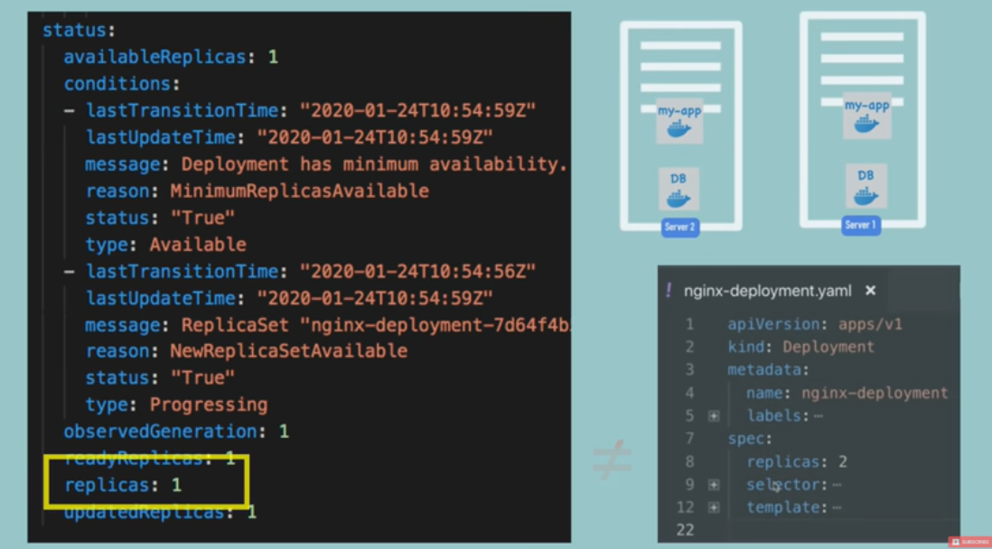

ETCD holds the CURRENT STATUS of K8s.

18)

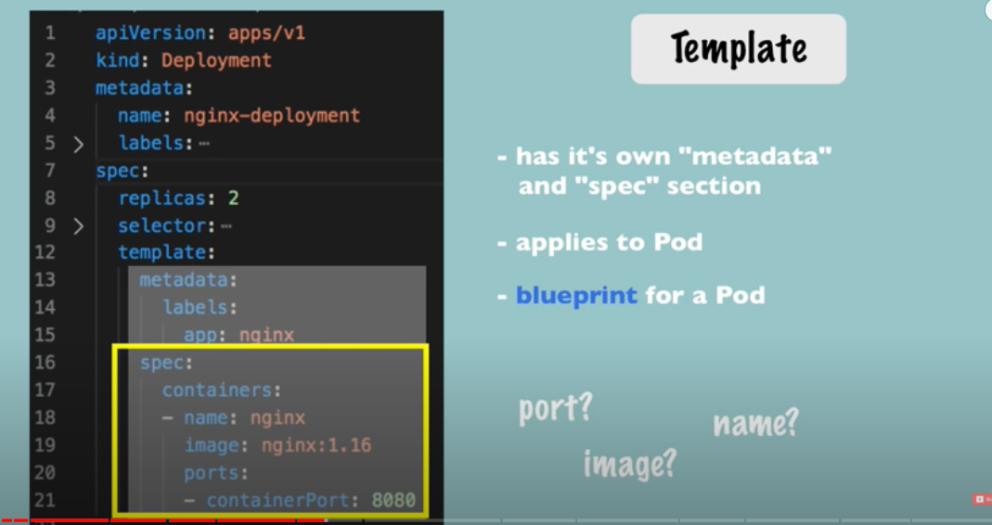

19)

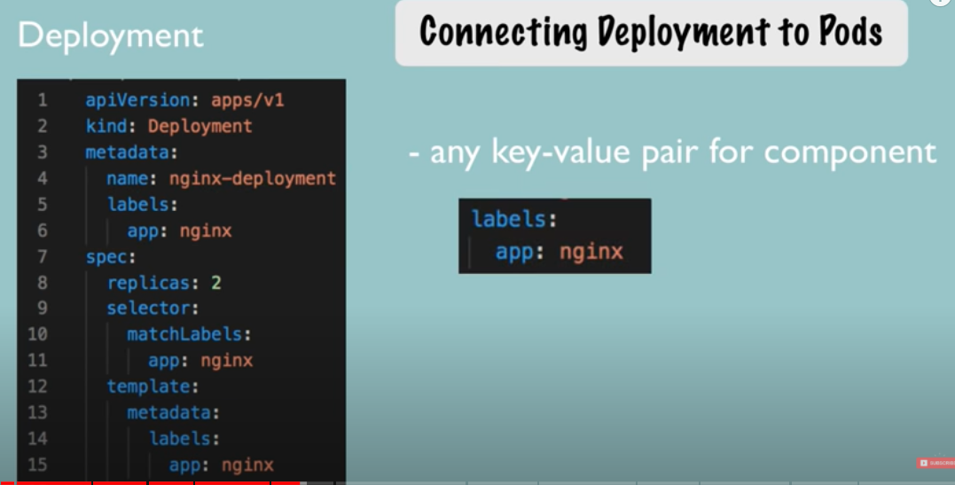

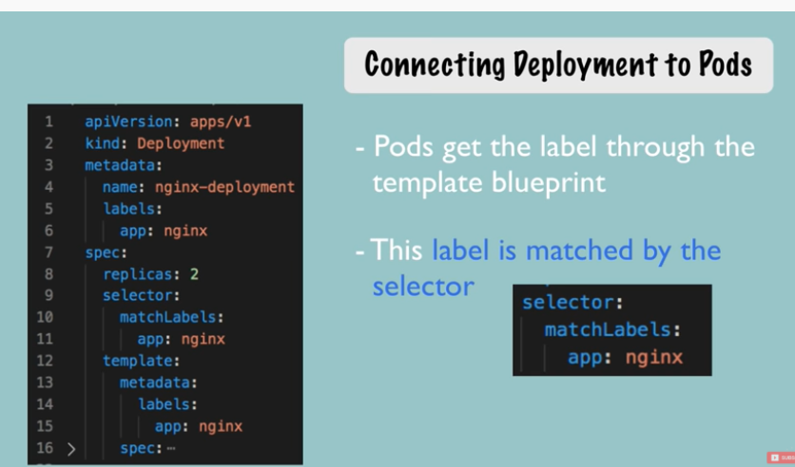

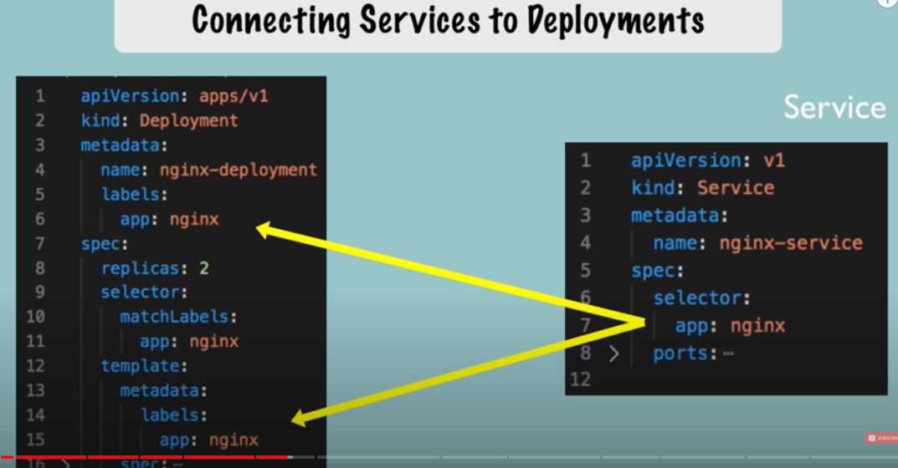

20)

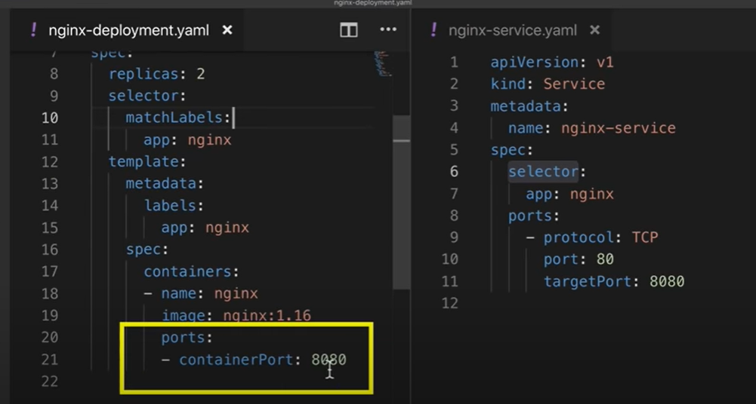

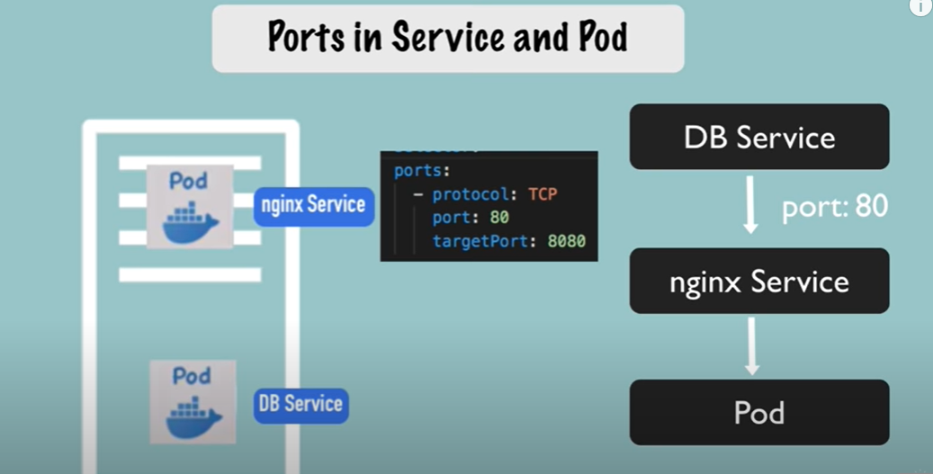

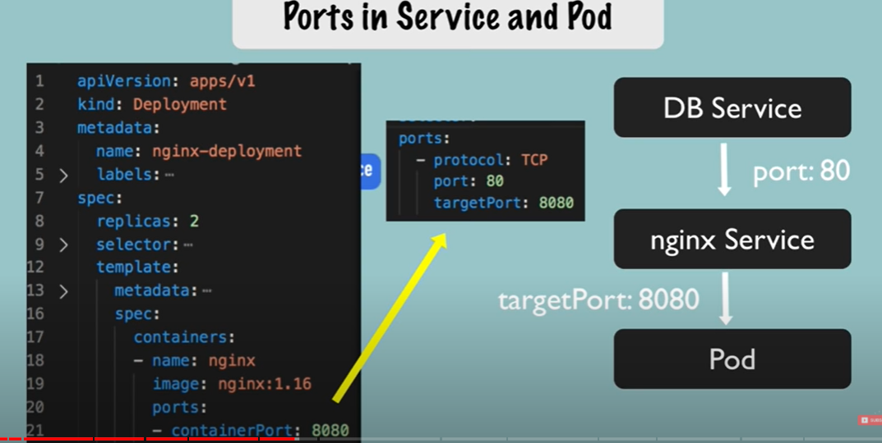

21)

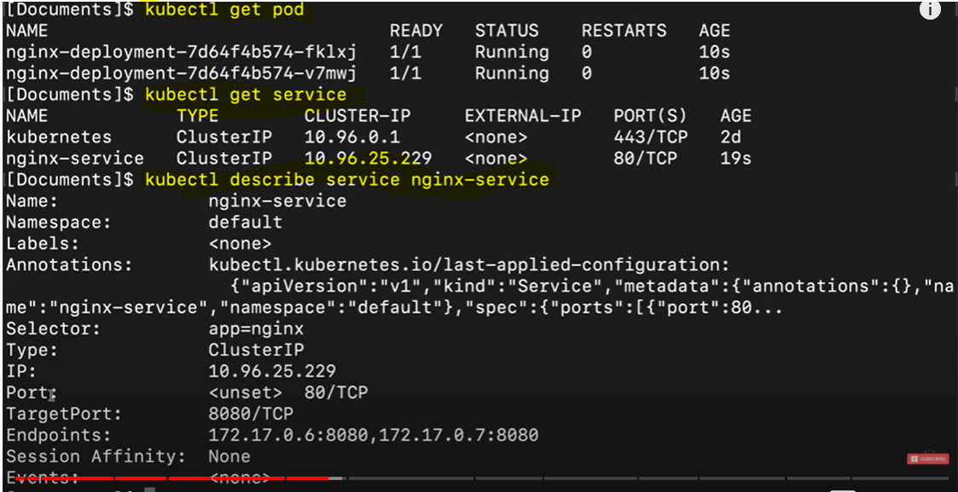

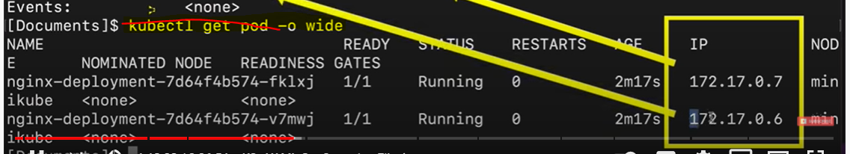

Get Updated details of Deployment i.e. check how STATUS is getting saved in to .yaml file..



Deployment gets Deleted if we delete config file…..

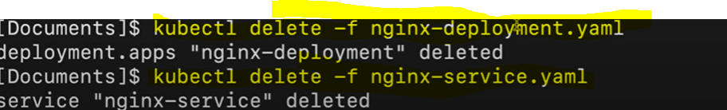

22)

Real time Set uP::

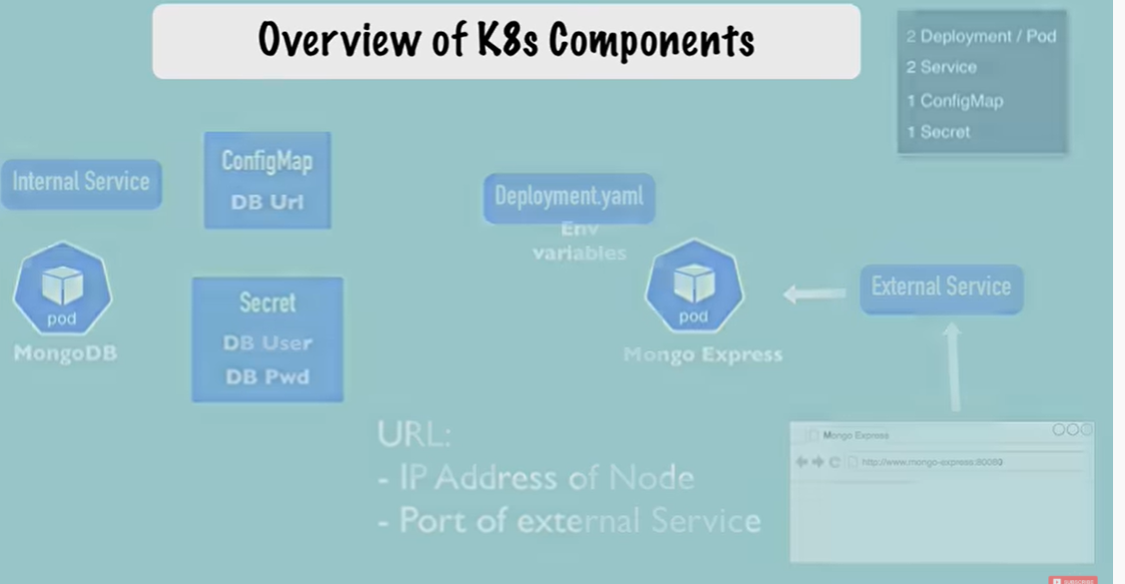

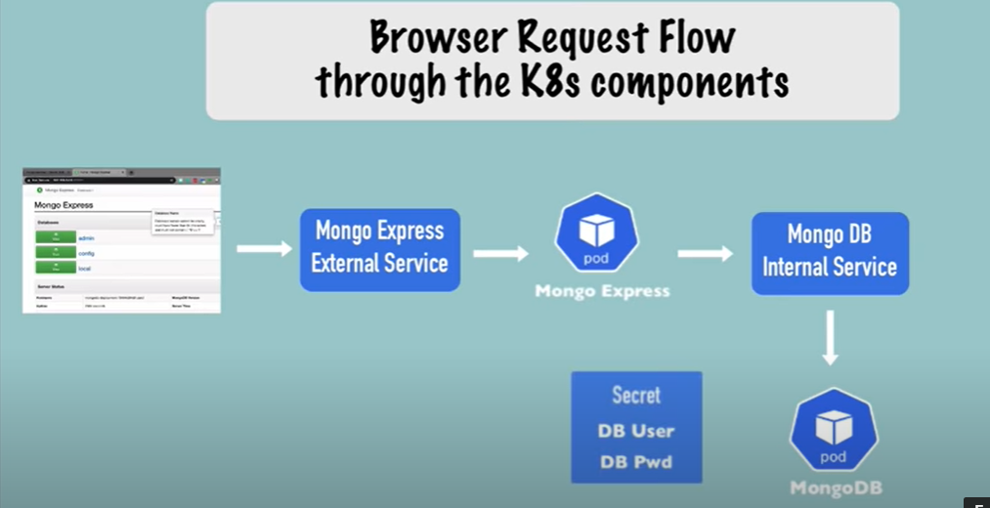

Deployment Set up using config .yaml file:

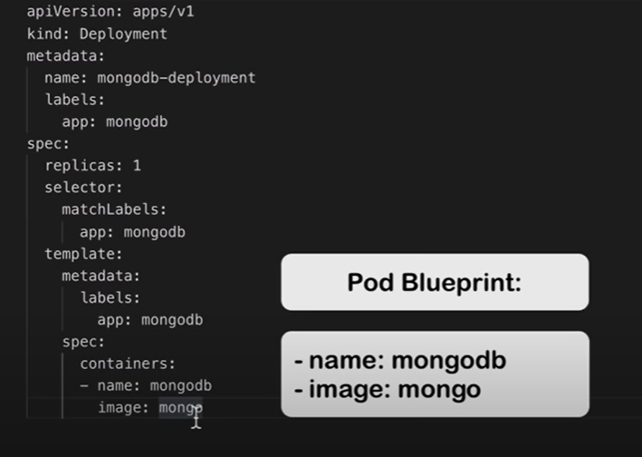

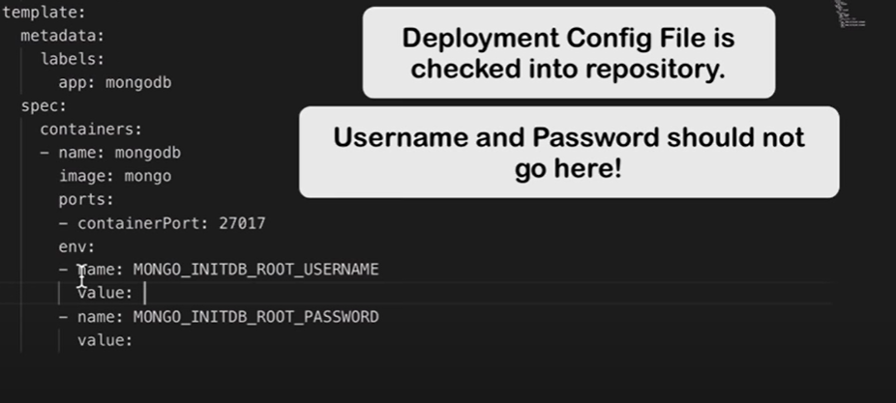

Secret Lives in K8s and not in Repository…

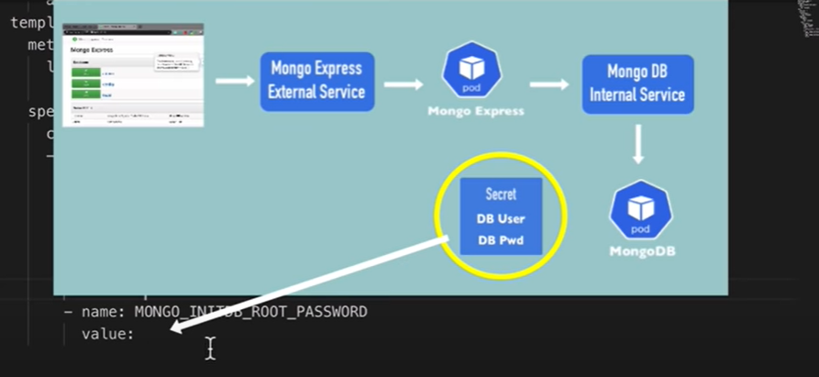

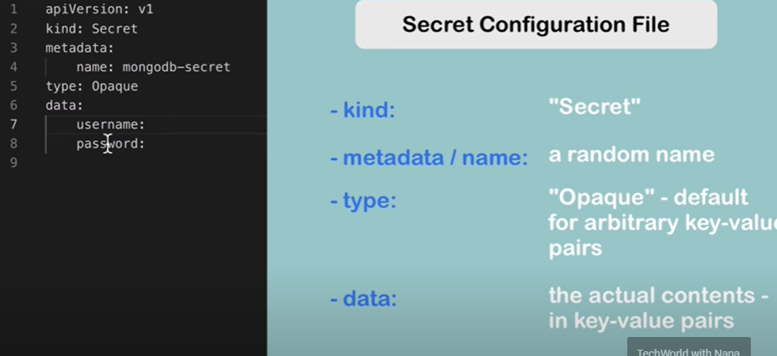

Convert plain text into base 64 encrypted text so ideally we should convert username and password in to base64.

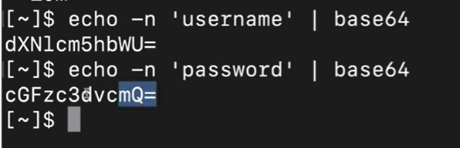

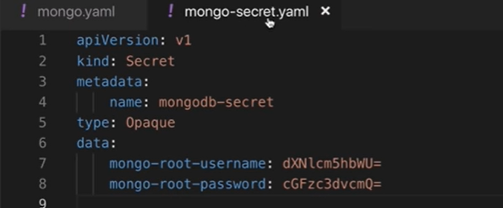

Apply secret :

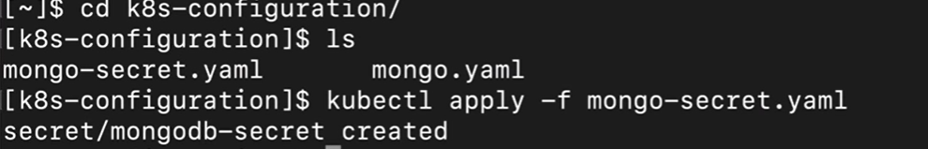

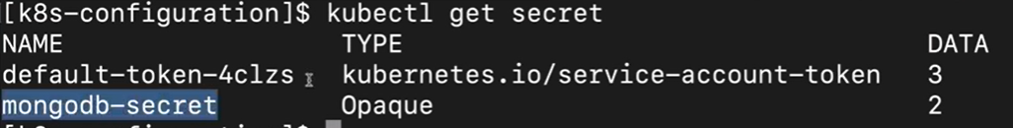

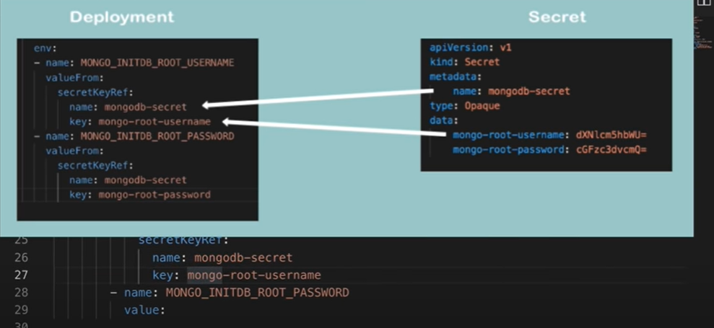

23)Lets Create Internal Service related Config in same .yaml file :

--- ===> 3 dot is seperator of another .yaml file in to same deployment.

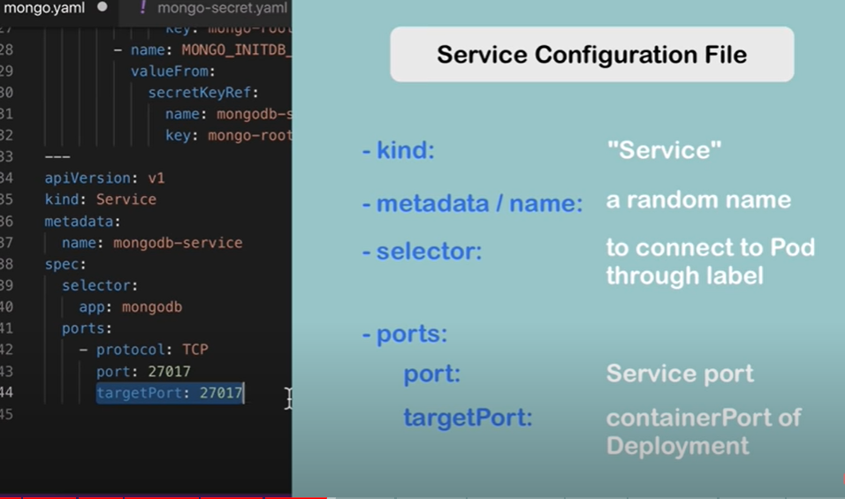

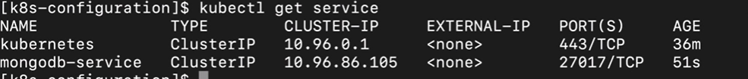

Get all components and filter them using Mongo..

* 1. Now create the mongo express server which can be accessed from external service…

External detaisl we will put in config-map..

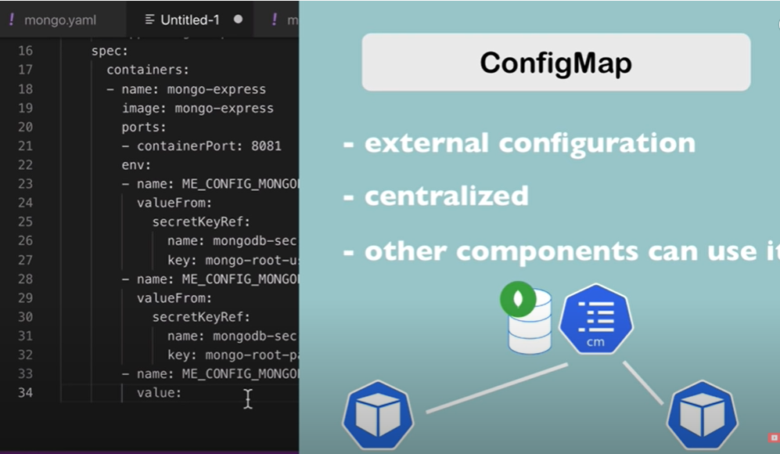

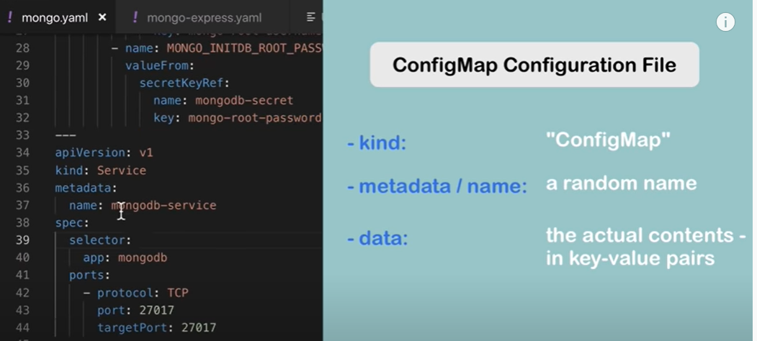

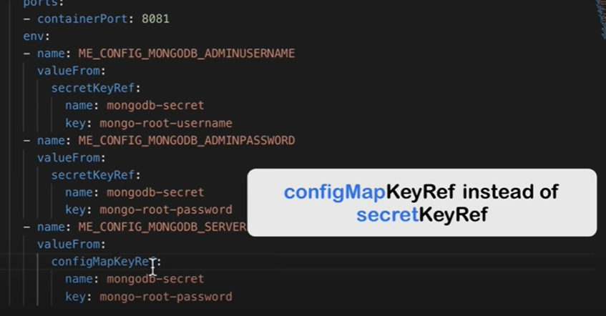

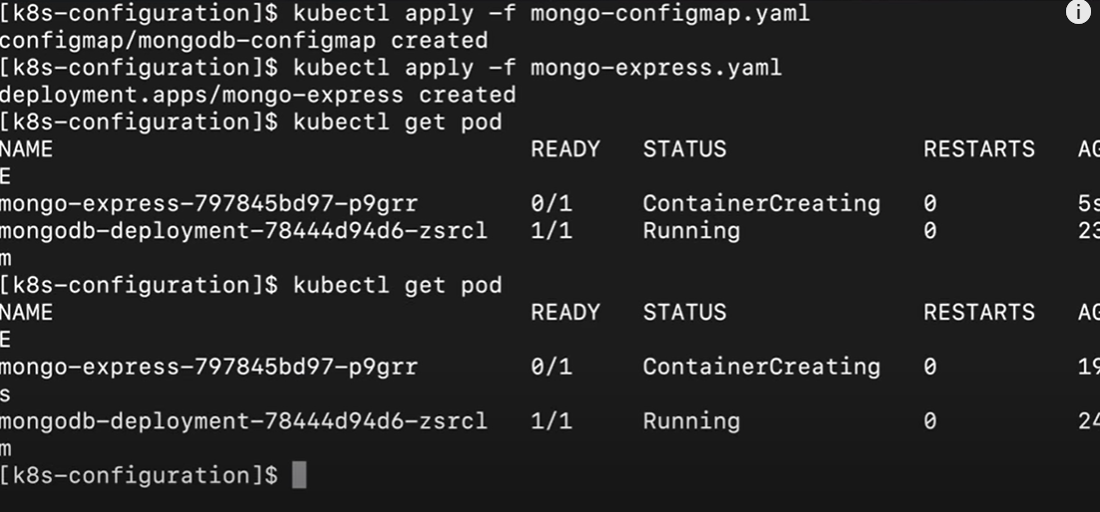

* 1. Now Create external Service which could access Mongo Express.

Node Port :: Used for external Service.

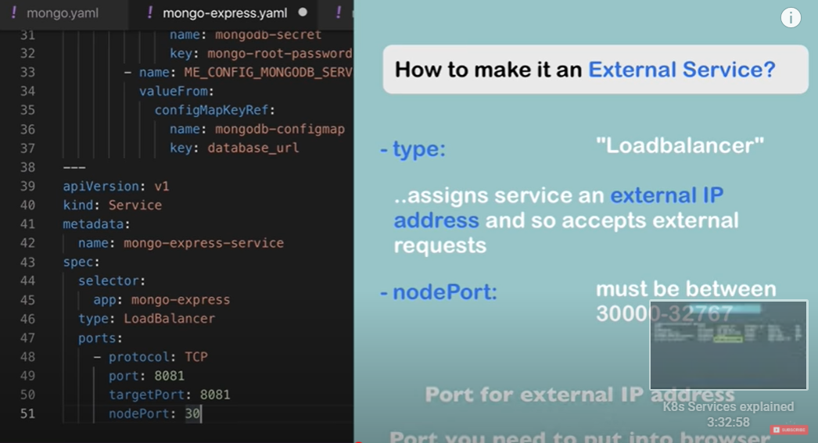

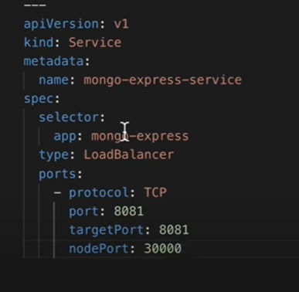

===> External Service Node Creation.

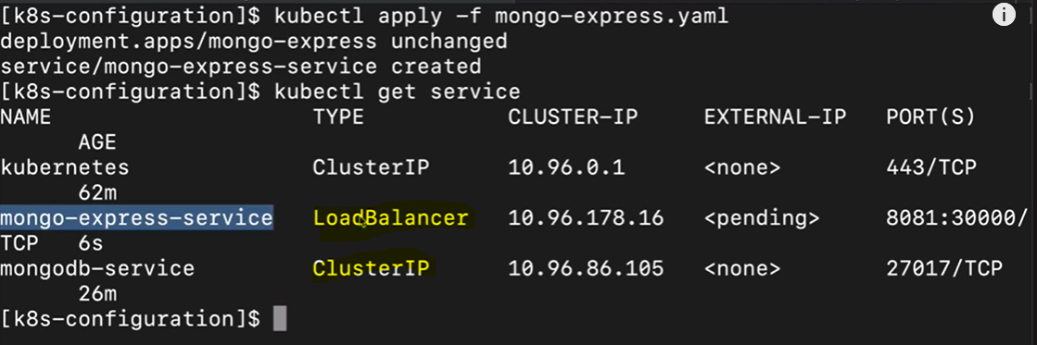

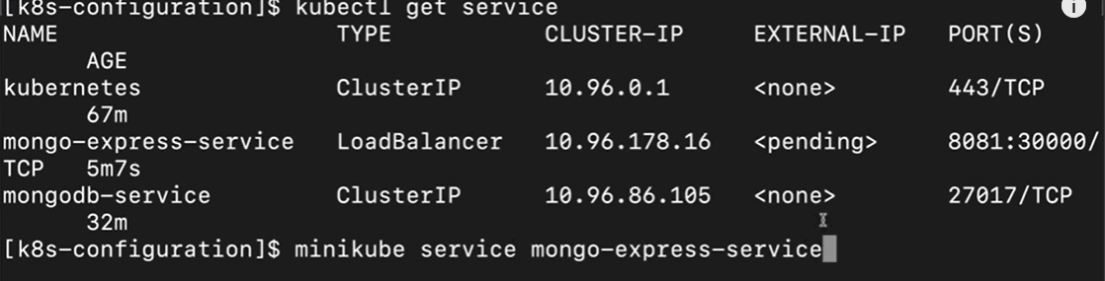

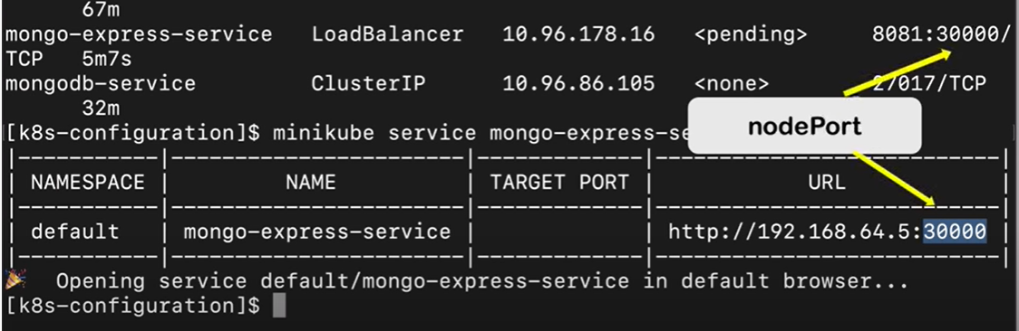

Full Working:

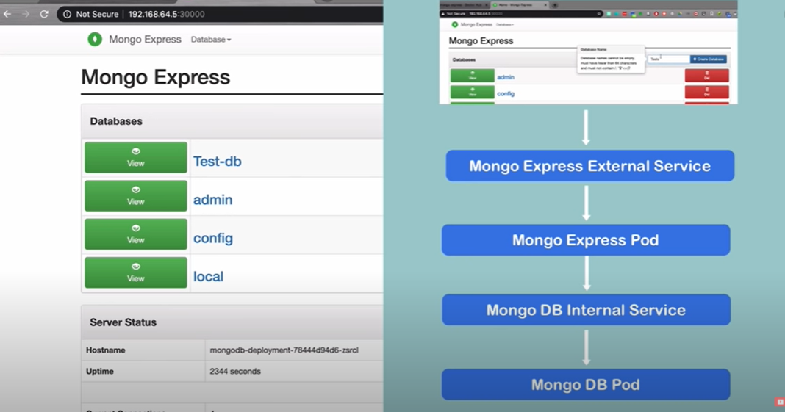

26)

=============== Istio and Service Mesh=======================



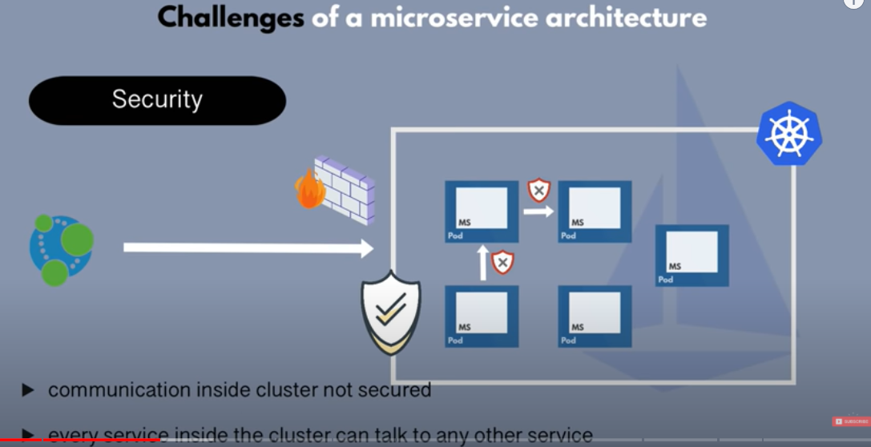

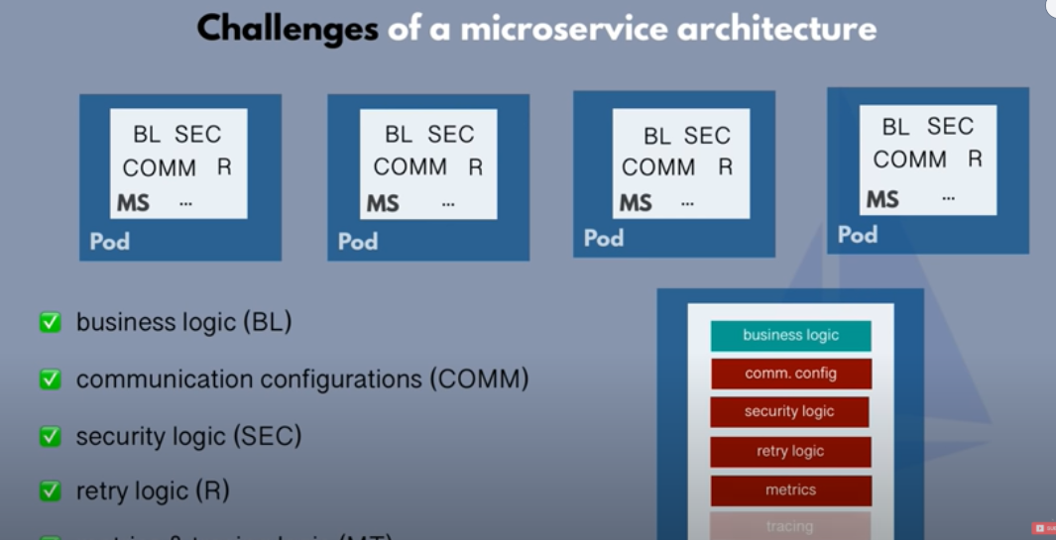

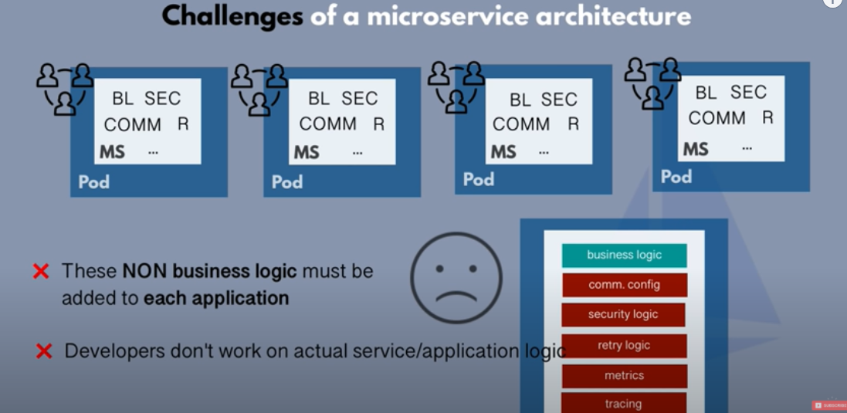

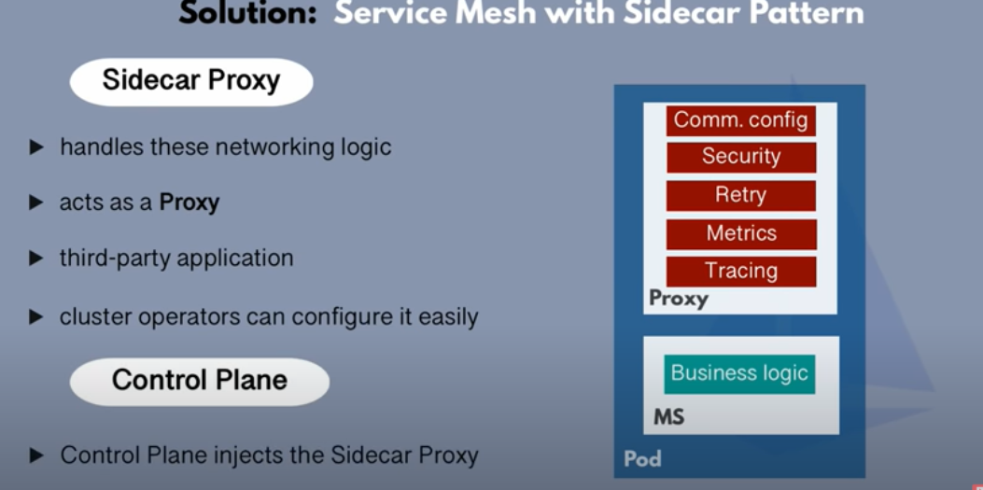

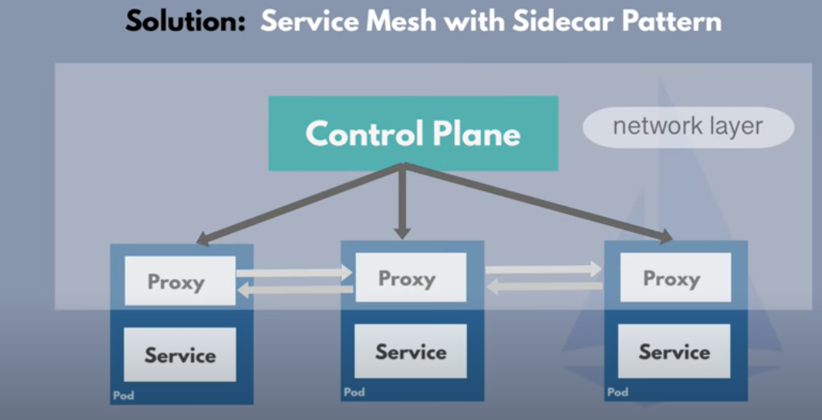

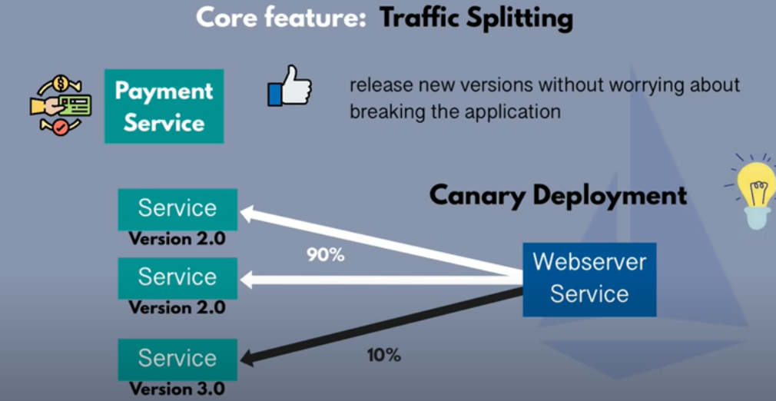

* 1. ISTIO Architecture =======================>

